eProject Report
Project Title: Venus Handicrafts - Official Brand Website
Client: Venus Handicrafts Pvt. Ltd.
Prepared By: [Your Name/Team Name]
Date: March 27, 2026

Acknowledgements
I would like to express my sincere gratitude to the management of Venus Handicrafts for providing the vision and content for this project. Their commitment to preserving traditional craftsmanship and promoting it on a global scale served as the primary inspiration.

I am also thankful to the open-source community for providing the tools and libraries (Font Awesome, Google Fonts) that made the development process efficient and the final product visually appealing. Special thanks to the stakeholders who provided valuable feedback during the development phase, ensuring the website aligns perfectly with the brand's identity and business goals.

eProject Synopsis
The Venus Handicrafts website is a modern, responsive, and informative web application designed to serve as the digital storefront for a certified handicraft manufacturer and exporter. The project's primary goal is to establish a strong online presence, showcase the company's rich 50-year legacy, and present its diverse product catalog to a global audience of importers, wholesalers, and retailers.

The website is built using core web technologies: HTML5 for structure, CSS3 for styling and responsive layout, and JavaScript for interactivity and dynamic content loading. A key feature is its use of external JSON data to dynamically populate the products and FAQs sections. This decoupling of content from code makes the site easily maintainable and scalable, allowing the company to update its product catalog without modifying the core HTML structure.

Key features include a sticky navigation bar, a compelling hero section, a detailed "About Us" section, dynamic product and FAQ displays, a static gallery, a contact form with client-side validation, and a comprehensive sitemap in the footer. The design emphasizes elegance, readability, and a user-friendly experience across all devices, from desktops to mobile phones.

eProject Analysis
1. Problem Statement
Venus Handicrafts, despite being a renowned exporter since 1972, lacked a cohesive, modern online platform to effectively present its brand story and extensive product range to international clients. The absence of a centralized digital presence made it difficult for potential buyers to explore the collection, understand the company's craftsmanship, and initiate business inquiries.

2. Proposed Solution
This project proposes the development of a comprehensive brand website that acts as a digital catalog and a business hub. The solution focuses on:

Brand Storytelling: Effectively communicating the company's heritage and values through dedicated sections.

Product Showcase: Displaying products in an organized, visually appealing grid format, powered by a dynamic JSON data source.

Lead Generation: Providing a simple contact form to capture business inquiries from potential clients.

Information Hub: Presenting important information like FAQs, contact details, and a sitemap for easy navigation.

Global Reach: Ensuring the website is responsive and accessible to a global audience on various devices.

3. Target Audience
Primary: International importers, wholesalers, and retailers of home decor and handicrafts.

Secondary: Individual buyers and interior designers looking for unique, high-quality artisanal pieces.

4. Functional Requirements
The website must be responsive and function correctly on desktop, tablet, and mobile devices.

It must have a navigation menu that links to all major sections (Home, About, Products, Gallery, Contact, Site Map, FAQs).

The Products section must dynamically load its content from an external data.json file.

The FAQs section must dynamically load its content from the same data.json file and include interactive toggle functionality for answers.

The contact form must include client-side validation to ensure all fields are filled before submission.

The navigation must be sticky, remaining at the top of the viewport as the user scrolls.

5. Non-Functional Requirements
Performance: The website should load quickly, with optimized images and minimal external dependencies.

Usability: The interface should be intuitive, with clear labels and easy navigation.

Reliability: The dynamic content loading should have a fallback mechanism in case the JSON file fails to load.

Maintainability: The code should be well-structured, commented, and separate HTML, CSS, and JS files for easy updates.

eProject Design
DFD's (Data Flow Diagram)
Level 0 DFD (Context Diagram):
This diagram shows the entire system as a single process (The Venus Handicrafts Website). The two external entities are the User (Client) and the Data Server.

User: Sends requests (clicks, form submissions) to the website. Receives information (pages, product data, form confirmation).

Data Server: The website sends a request for data.json. The server returns the JSON file with product and FAQ data.

![Venus Handicrafts Level 0 DFD (Context Diagram) - A textual representation: A central circle labeled 'Venus Handicrafts Website' is connected to two rectangles. One rectangle labeled 'User' has an arrow pointing to the central circle labeled 'HTTP Requests', and an arrow from the central circle to the user labeled 'HTML/CSS/JS Content'. Another rectangle labeled 'Data Server' has a double-headed arrow with the central circle, labeled 'Request data.json' and 'Return data.json'.](A textual representation is provided as requested.)

Level 1 DFD:
This diagram breaks down the main process into sub-processes: 1.0 Serve Static Content, 2.0 Handle Navigation, and 3.0 Load Dynamic Content.

1.0 Serve Static Content: The user requests a page load. The system sends the main HTML/CSS/JS and static images (like hero image, gallery images).

2.0 Handle Navigation: The user clicks a navigation link. The system uses smooth scrolling to navigate to the relevant section within the same page.

3.0 Load Dynamic Content:

The JavaScript engine sends a request to the Data Server for data.json.
The Data Server returns the JSON file.
The JavaScript engine parses the data.
It then updates the DOM (Document Object Model) to render the Products and FAQs sections. It also attaches event listeners to the FAQ toggles.
FlowCharts
Flowchart 1: Website Initialization and Data Loading
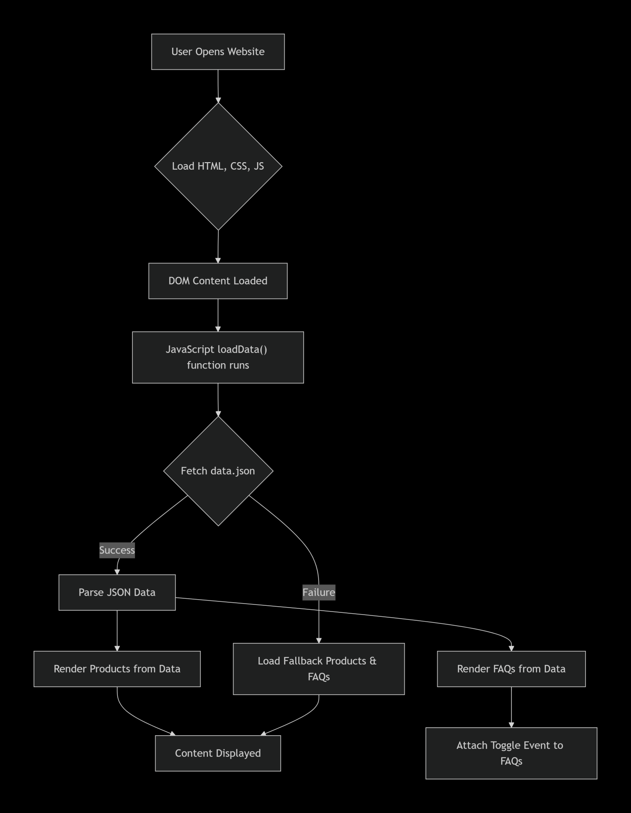
Flowchart 2: Contact Form Submission
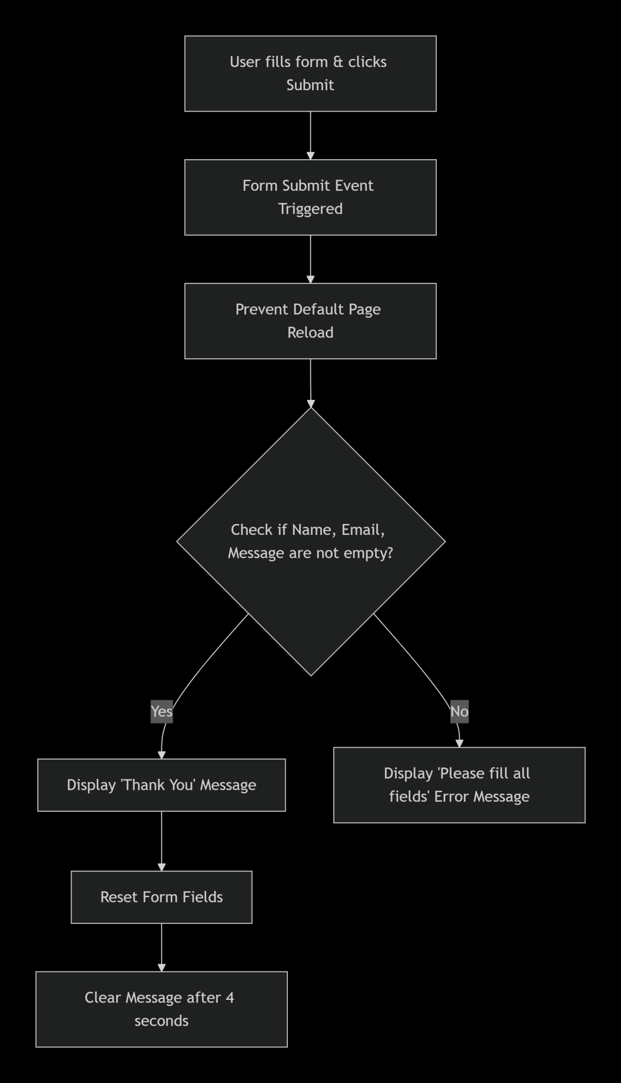

Process Diagrams
High-Level System Architecture Diagram:
This diagram illustrates how the different components of the website interact.

User's Browser (Client): Requests and renders the website.

Static Assets (Server): Hosts the .html, .css, .js files and image assets (hero.jpg, gallery images). Serves these files to the client.

Data Source (Server): Hosts the data.json file. The client-side JavaScript fetches this file.

Client-Side Logic (JavaScript): Handles all interactivity: DOM manipulation, event handling (menu toggles, form submission), dynamic rendering, and data fetching.

Screen Shot's
(Note: These are descriptions of what the screenshots would show. In a real report, you would paste actual images.)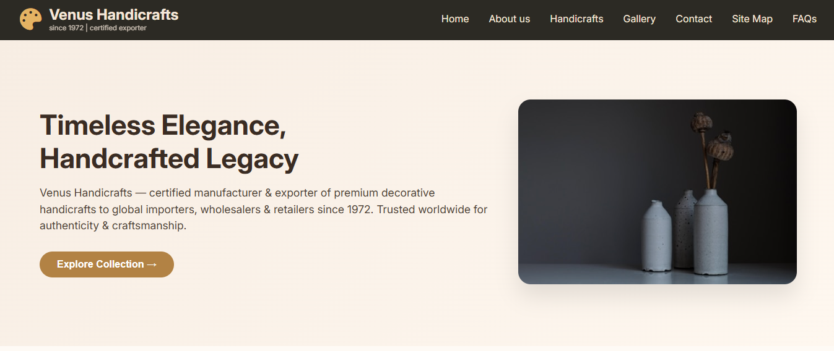

Screenshot 2: About Us & Products Section

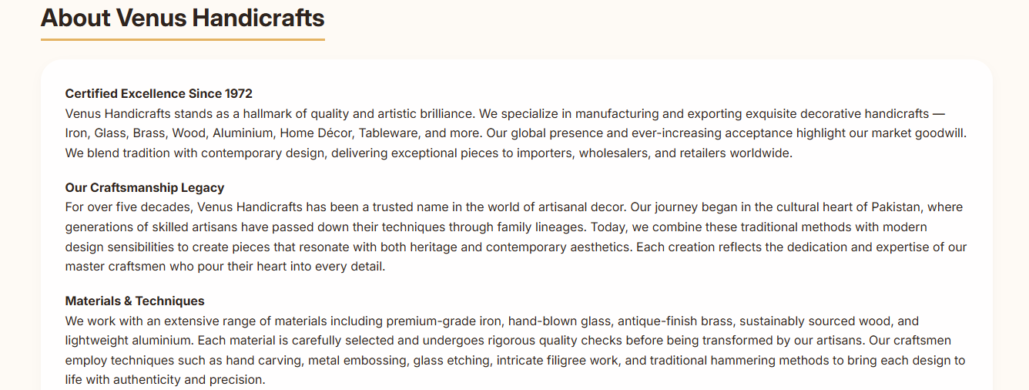
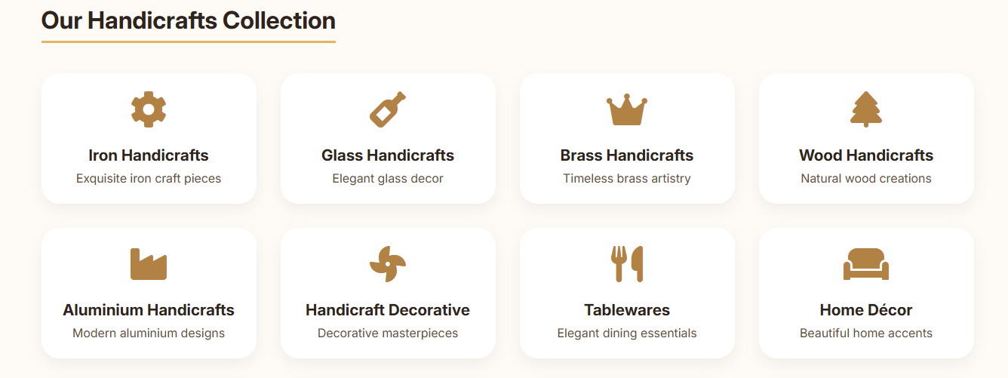
Screenshot 3: Gallery Section & Contact Form

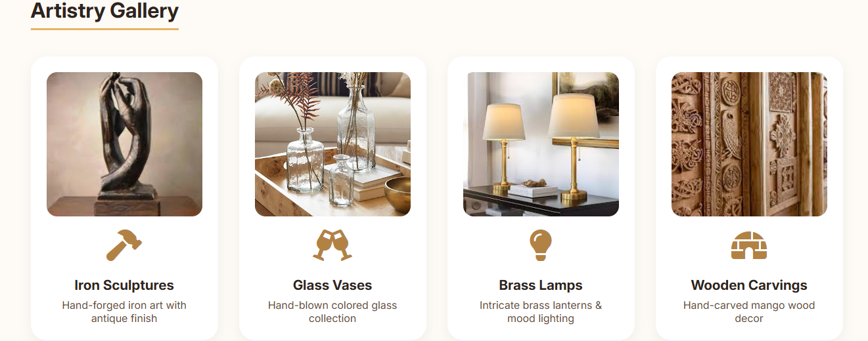
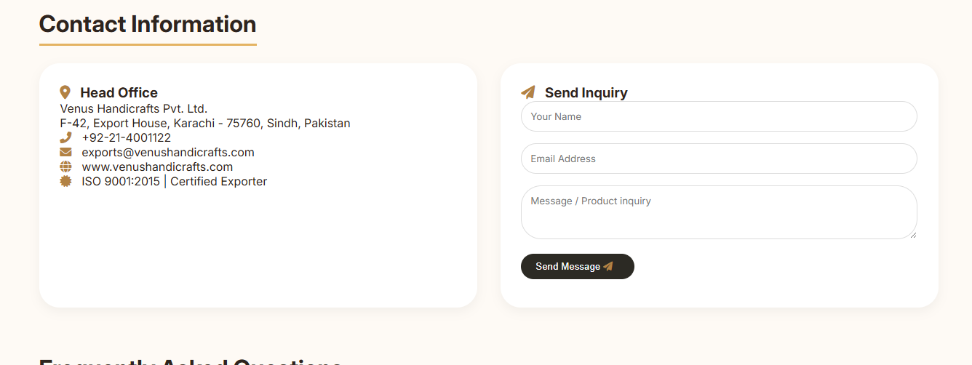
Screenshot 4: FAQs & Footer Sitemap

Displays the FAQ section with several questions collapsed. One question is expanded, showing its answer.

Shows the footer with the 4-column sitemap containing navigation links, resources, categories, and dynamic product tags.

Screenshot 5: Mobile Responsiveness (Mobile View)
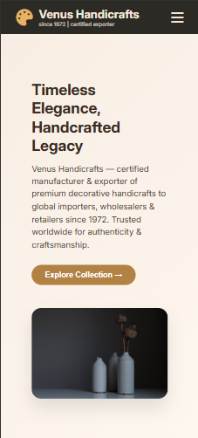

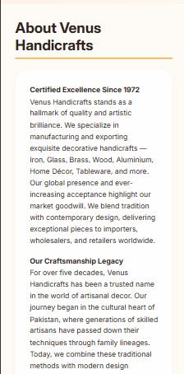
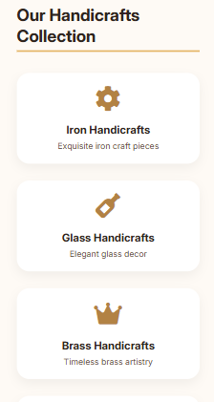
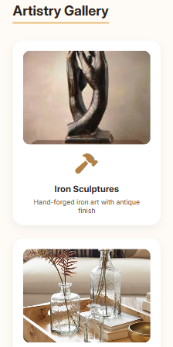
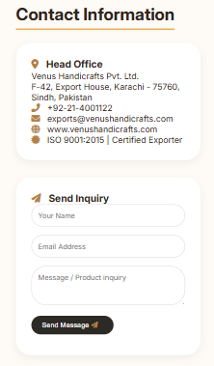
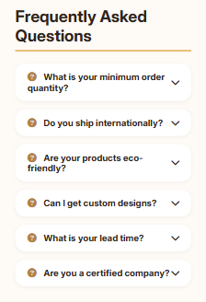
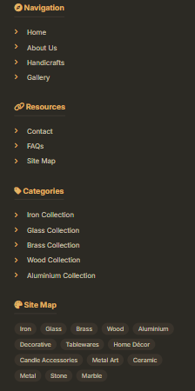

Source Code with Comments
The source code is provided in three files: index.html, style.css, and script.js. The comments within the code explain the functionality.

1. index.html (See the full HTML code provided in the initial prompt, with comments added)

html
<!DOCTYPE html>
<html lang="en">
<head>
<meta charset="UTF-8">
<meta name="viewport" content="width=device-width, initial-scale=1.0, user-scalable=yes">
<title>Venus Handicrafts | Since 1972</title>
<!-- External Fonts and Icons -->
<link href="https://fonts.googleapis.com/css2?family=Inter:opsz,wght@14..32,300;14..32,400;14..32,600;14..32,700&display=swap" rel="stylesheet">
<link rel="stylesheet" href="https://cdnjs.cloudflare.com/ajax/libs/font-awesome/6.0.0-beta3/css/all.min.css">
<link rel="stylesheet" href="style.css">
</head>
<body>

<div class="top-bar">
<div class="navbar">
<div class="logo-area">
<i class="fas fa-palette logo-icon"></i>
<div class="logo-text">
<h1>Venus Handicrafts</h1>
<p>since 1972 | certified exporter</p>
</div>
</div>
<!-- Mobile Menu Button -->
<div class="mobile-menu" id="mobileMenuBtn">
<i class="fas fa-bars"></i>
</div>
<!-- Navigation Links, hidden on mobile until button click -->
<ul class="nav-links" id="navLinks">
<li><a href="#home">Home</a></li>
<li><a href="#about">About us</a></li>
<li><a href="#products">Handicrafts</a></li>
<li><a href="#gallery">Gallery</a></li>
<li><a href="#contact">Contact</a></li>
<li><a href="#sitemap">Site Map</a></li>
<li><a href="#faq">FAQs</a></li>
</ul>
</div>
</div>

<!-- The rest of the HTML structure follows, with semantic sections for each part of the site -->
<!-- ... (Rest of the HTML structure is as provided) ... -->

<script src="script.js"></script>
</body>
</html>
2. style.css (See the full CSS code provided in the initial prompt, with comments added)

css
/* style.css */
* {
margin: 0;
padding: 0;
box-sizing: border-box;
}

body {
font-family: 'Inter', sans-serif;
background-color: #fefaf5; /* Warm off-white background */
color: #2e241f;
scroll-behavior: smooth; /* Enables smooth scrolling for anchor links */
}

/* --- Navigation Bar Styles --- */
.top-bar {
background: #2c2a24; /* Dark, earthy background for navbar */
color: #f5e7d9;
padding: 0.8rem 2rem;
position: sticky; /* Keeps navbar at the top */
top: 0;
z-index: 1000;
}

/* ... (Rest of the CSS is as provided) ... */

/* --- Responsive Styles for Mobile --- */
@media (max-width: 768px) {
.mobile-menu {
display: block; /* Shows hamburger menu on mobile */
}
.nav-links {
display: none; /* Hides the full menu by default */
width: 100%;
flex-direction: column;
align-items: center;
gap: 1rem;
padding: 1rem 0;
}
.nav-links.show {
display: flex; /* Shown when hamburger menu is clicked */
}
/* ... other responsive styles ... */
}
3. script.js (See the full JavaScript code provided in the initial prompt, with comments added)

javascript
// script.js

// --- Mobile Menu Toggle ---
const mobileBtn = document.getElementById('mobileMenuBtn');
const navLinks = document.getElementById('navLinks');
if(mobileBtn) {
mobileBtn.addEventListener('click', () => {
navLinks.classList.toggle('show'); // Toggles the 'show' class to display/hide menu
});
}

// --- Contact Form Handler with Client-Side Validation ---
const inquiryForm = document.getElementById('inquiryForm');
const feedback = document.getElementById('formFeedback');
if(inquiryForm) {
inquiryForm.addEventListener('submit', (e) => {
e.preventDefault(); // Stops the page from refreshing
const name = document.getElementById('nameInput').value.trim();
const email = document.getElementById('emailInput').value.trim();
const msg = document.getElementById('msgInput').value.trim();
if(name && email && msg) {
// If all fields are filled, show success message
feedback.innerHTML = '<i class="fas fa-check-circle" style="color:green;"></i> Thank you! Our team will contact you soon.';
feedback.style.color = '#2c7a47';
inquiryForm.reset();
setTimeout(() => { feedback.innerHTML = ''; }, 4000);
} else {
// If any field is empty, show error
feedback.innerHTML = '<i class="fas fa-exclamation-triangle"></i> Please fill all fields.';
feedback.style.color = '#b33';
}
});
}

// --- Helper function to attach click toggles for FAQ items ---
function attachFaqToggles() {
document.querySelectorAll('.faq-question').forEach(question => {
question.removeEventListener('click', question._listener);
const handler = function() {
const answer = this.nextElementSibling;
const icon = this.querySelector('.fa-chevron-down, .fa-chevron-up');
if(answer.style.display === 'none' || answer.style.display === '') {
answer.style.display = 'block';
if(icon) icon.classList.replace('fa-chevron-down', 'fa-chevron-up');
} else {
answer.style.display = 'none';
if(icon) icon.classList.replace('fa-chevron-up', 'fa-chevron-down');
}
};
question.addEventListener('click', handler);
question._listener = handler;
});
}

// --- Main function to load data from data.json ---
async function loadData() {
try {
const response = await fetch('data.json'); // Fetch the JSON file
if (!response.ok) throw new Error('Failed to load data.json');
const data = await response.json();

// --- Render Products Dynamically ---
const productsContainer = document.getElementById('productsContainer');
if (productsContainer && data.products) {
productsContainer.innerHTML = '';
data.products.forEach(product => {
const card = document.createElement('div');
card.className = 'product-card';
const iconClass = product.icon ? product.icon : 'fas fa-gem';
card.innerHTML = `<i class="${iconClass}"></i><h3>${escapeHtml(product.name)}</h3><p>${escapeHtml(product.description)}</p>`;
productsContainer.appendChild(card);
});
}

// --- Render FAQs Dynamically ---
const faqContainer = document.getElementById('faqContainer');
if (faqContainer && data.faqs) {
faqContainer.innerHTML = '';
data.faqs.forEach((faq) => {
const faqItem = document.createElement('div');
faqItem.className = 'faq-item';
faqItem.innerHTML = `
<div class="faq-question"><span><i class="fas fa-question-circle"></i> ${escapeHtml(faq.question)}</span><i class="fas fa-chevron-down"></i></div>
<div class="faq-answer" style="display: none;">${escapeHtml(faq.answer)}</div>
`;
faqContainer.appendChild(faqItem);
});
attachFaqToggles(); // Make the new FAQs interactive
}
} catch (error) {
console.error('Error loading data.json:', error);
// Fallback: Show static product and FAQ content if JSON fails to load
// ... (fallback code as provided) ...
}
}

// Helper function to escape HTML to prevent XSS attacks
function escapeHtml(str) {
if (!str) return '';
return str.replace(/[&<>]/g, function(m) {
if (m === '&') return '&amp;';
if (m === '<') return '&lt;';
if (m === '>') return '&gt;';
return m;
});
}

// Start the data loading process when the page loads
loadData();
User Guide
This guide provides instructions for a user (visitor) to navigate and use the Venus Handicrafts website.

1. Getting Started

Open your web browser (Chrome, Firefox, Safari, etc.).

Enter the website URL (e.g., www.venushandicrafts.com) in the address bar.

The homepage will load, displaying the hero section with a welcome message and the main navigation menu at the top.

2. Navigating the Website

Use the menu bar at the top to jump to any section of the website:

Home: Takes you back to the top of the page.

About us: Scrolls to the detailed company history and values.

Handicrafts: Scrolls to the product catalog.

Gallery: Scrolls to a visual gallery of the crafts.

Contact: Scrolls to the contact information and inquiry form.

Site Map: Scrolls to the footer for a structured overview of links.

FAQs: Scrolls to the frequently asked questions section.

On a mobile device, the menu is replaced by a "hamburger" icon (☰). Tap it to open the navigation menu.

3. Exploring Products

Go to the Handicrafts section.

You will see a grid of product categories (e.g., Iron Handicrafts, Glass Handicrafts).

Each card shows a title and a brief description of the category.

4. Viewing the Gallery

Go to the Gallery section.

Browse through the images and their titles to see examples of the products.

5. Contacting the Company

Go to the Contact section.

You will see the company's address, phone, email, and website on the left.

On the right, there is an Inquiry Form.

Enter your Name.

Enter a valid Email Address.

Write your Message or product inquiry.

Click the Send Message button.

You will see a confirmation message if all fields are filled correctly.

6. Finding Answers in FAQs

Go to the FAQs section.

You will see a list of common questions. Click on any question to reveal the answer. Click it again to hide the answer.

7. Using the Site Map (Footer)

Scroll to the very bottom of the page.

The footer is organized into columns: Navigation, Resources, Categories, and Site Map.

Click on any link to quickly jump to that section or related information.

Developer’s Guide
This guide provides a technical overview of the project's modules for future developers.

Module Descriptions
The application is built with a standard front-end architecture consisting of three core modules represented by the three main files.

Module 1: Structure Module (index.html)

Purpose: Defines the content structure and semantics of the webpage.

Key Elements:

<head>: Contains meta-information, links to external CSS and fonts. The viewport tag ensures proper scaling on mobile devices.

<body>: Organized into semantic sections (<section>) for Home, About, Products, Gallery, Contact, and FAQ. Each section has a unique id for navigation.

Dynamic Containers: The <div id="productsContainer"> and <div id="faqContainer"> are empty placeholders. They are targeted by the JavaScript module to inject dynamic content.

Static Content: The gallery section is static HTML, demonstrating a mixed approach. The contact form is also static.

Footer Sitemap: Contains a #dynamicTags container that can be enhanced by JavaScript.

Module 2: Presentation Module (style.css)

Purpose: Handles all visual styling and responsive layout.

Key Sections:

Base Styles: Resets margins, sets default font, and background color.

Component Styles: Defines the look for the navbar, hero section, product cards, gallery cards, contact form, and footer.

Utility Classes: Uses .container to center content and provide padding.

Media Queries: Implements a mobile-first or desktop-first approach (a combination) with breakpoints at 900px and 768px. The main mobile menu logic is toggled by JavaScript, but the CSS provides the .nav-links.show class.

Interactive States: Includes :hover effects for buttons and links, and a loader animation.

Module 3: Behavior & Data Module (script.js)

Purpose: Manages all client-side interactivity, data fetching, and DOM manipulation.

Key Functions:

loadData(): An asynchronous function that is the heart of the dynamic content. It fetches data.json, parses it, and calls functions to render products and FAQs. It includes a try...catch block for robust error handling and a fallback mechanism.

attachFaqToggles(): A function that programmatically adds click event listeners to FAQ questions. It toggles the display of the answer and changes the chevron icon.

Contact Form Handler: An event listener on the form that validates input and provides user feedback without a page reload.

Mobile Menu Toggle: An event listener on the hamburger button that toggles the show class on the navLinks element.

escapeHtml(): A helper function that sanitizes dynamic content to prevent Cross-Site Scripting (XSS) vulnerabilities. This is a critical security measure.

Data Module (data.json)

Purpose: Acts as a lightweight database for dynamic content.

Structure: Contains three main arrays:

products: An array of objects, each with name, icon (FontAwesome class), and description.

gallery: (Not used dynamically in the current JS but present for potential future expansion).

faqs: An array of objects, each with a question and answer.

Future Development & Extension

Adding New Products/FAQs: Simply edit the data.json file. The loadData() function will automatically render the new content.

Adding a New Module: Create a new <section> in index.html and a corresponding container. Write a new function in script.js to fetch or manipulate data for that section.

Backend Integration: The contact form currently uses client-side validation only. To make it functional, a developer would need to modify the form's submit event listener to send the form data (using fetch) to a backend API endpoint.

Image Optimization: The current gallery uses placeholder image names. A developer should replace these with actual, optimized images and update the src attributes in index.html.

